

American International University-Bangladesh (AIUB)  
**Department of Computer Science  
CSC 2210 Object Oriented Analysis and Design (OOAD)**

**Section: C**

**Student Housing Management System**

An Object-Oriented Analysis and Design (OOAD) Project Submitted

By

Rudro Rifat Al Mamun **19-39909-1**

Tamhid Mostafa Ansari **18-39142-3**

Sumit Chandra Shovon **18-37115-1**

Khadiza Begum Himu **18-38904-3**

|  |  |
| --- | --- |
| **CO3:** Formulate a baseline document to perform feasibility study of a proposed project idea | Total Marks |
|  |
| Project Background Analysis [5] |  |
| Project Content Knowledge [5] |  |
| Project Feasibility Study [5] |  |
| **CO4:** Design a Complex engineering problem using UML Tools and explain the system using a project report and presentation | Total Marks |
|  |
| Diagram Standard [5] |  |
| Report Organization [5] |  |
| Presentation Delivery [5] |  |

**SCENERIO**

In a **student** housing management system, A flat owner and a student can create an account on a system. There A flat owner can create an ad for his/her available space. A Student can rent his/her preferable place from all ad. The system will check both flat owner’s and bachelor’s authentication through the system. The types of facilities are room, seat as well as flat. Students need to search to find their preferable place. There will be details about the places. After searching they can select a particular one and after that they can meet with the flat owner through the system. If their requirements meet they can sign agreement. There will be some facilities like Wi-fi, maid, laundry ,food and shifting They can pay money **by cash or by bank.**

**Project Background Analysis**

* **Write the background description that helps putting the project into the right context of a problem domain and gives everyone involved a common view of the project.**

**Answer:** The project name is student management system. It is related with the students, where we will provide house in a easiest way. There they can find house at reasonable price. We will give some facilities like- shifting, wifi, laundry, maid, food etc. In this app they can choose house by their requirement. After choosing the right option they can meet the owner of the house and discuss the matter.

* **What is the root cause of this problem? why is this problem is so important to consider?**

**Answer:** The project is “Student Housing Management System”. From the name of this project we can have a idea about this project. It is related with the students. There are 952404 students in Bangladesh. They are in different institute of different places. For the sake of education they need to move from one place to another place. So, they need a place to stay. As a student they can’t afford that much. So, the root cause of this problem is “Cost”. The financial situation is not same for everyone as Bangladesh is a poor country about 21.8% or nearly 36 million of the country’s population live the national poverty live under the national poverty line. 19 million of them are extreme poor (According to 2018). So many student’s can not afford high rent. Sometimes students may not always pay rent on time. For the sake student’s high costing problem should be consider with a great concern. Student’s are the future of our country. They are the backbone of future development of the country. In future they will be the leader. So, it is our foremost duty to maintain student’s present situation properly by sharing cost.

**Project Solution and Feasibility Analysis**

* **What are the solutions you are going to propose to deal with the problem? why is this   
   solution is particularly appropriate to solve the problem? Is the solution feasible to the meet the business objective?**

**Answer:** To solve this issue we are going to propose a platform where there will be a Landlord and student who want to make rent. First of all, the Landlord will register to our system and will request an ad including all information about his available space. The system will verify all information and will show it as an ad to the student. On the side, the Student will open an account by providing helping documents to prove he or she is a student. After that system will verify by a bank account whether he or she is a student. After performing verification, a student can log in to the system and will be able to see the existing ad. Whenever a student will request a seat or room. The system will connect with him and with a landlord for a meeting. By this, if both the student and the landlord will agree to make a deal, then the system will agree. later, the system will collect home rent before the 15th day of the month will provide it to the landlord. In the meantime, the system will do charge a fixed amount of commission in this transaction.

* **A short description of the software being specified and its purpose, including relevant benefits, objectives, and goals**

**Answer:** In this proposed software system, the service will be provided so that one student can easily find a place to live. It is the main goal. One landlord will be involved with this software system by giving information one’s available space. On the other hand, one student can invoke the available space as one’s requirements by this software system. For security, software system with charge an amount of security money to student. Software system will collect rent before 15th day of a month. By performing this service both the landlord and the student will be benefited since it is totally hassle free. This service is one of the objective of this software system. The software takes feedback about existing problem from both side in every month. So, that problem might be solved as per rules and regulation. By performing all these service, a hassle free house rent will be ensured.

* **Existing studies presented in the problem area. What are the existing software solutions   
   are available to solve the aforementioned problem?**

**Answer:** Now a day’s house rent procedure is one of the most serious problem. In this existing problem there are some system which is raised to solved. The most popular system are like B-property, Bikroy.com, ToletBD.com. They provide client two types of service, one is flat sale and the other is flat rent. Landlord gives details about their available space and the location. But they are not working against single seat and continuous service.

* **What makes this project new, innovative, interesting, or otherwise distinct from other similar projects? Does the project duplicate functionality already available in the market?**

**Answer:** The project is student housing management system. So, the interesting and innovative part is giving renting service to the students particularly. Usually, house owner’s doesn’t want to give their house to the students. But students go many different place for their studies so they need a seat or room or a flat to stay. So, our system will help them about this problem. We will also give them some extra service like- wifi, maid, food etc.

UML Diagram:

**Use Case Diagram:**

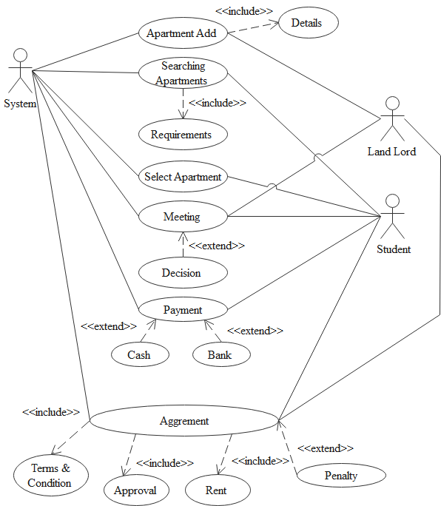

**Class Diagram Part 1:**

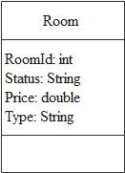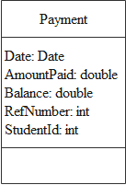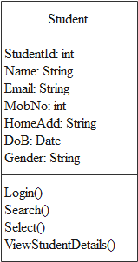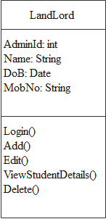

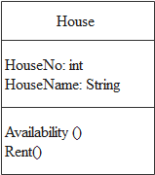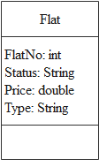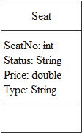

**Part 2:**

**Simple Class Relationship:**

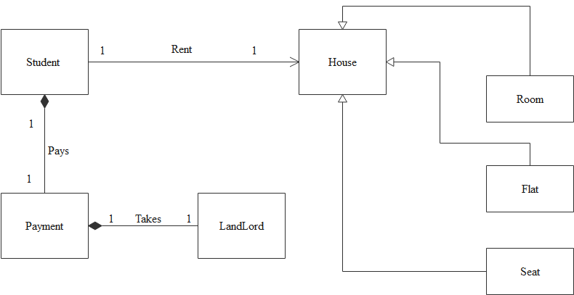

**Activity Diagram:**

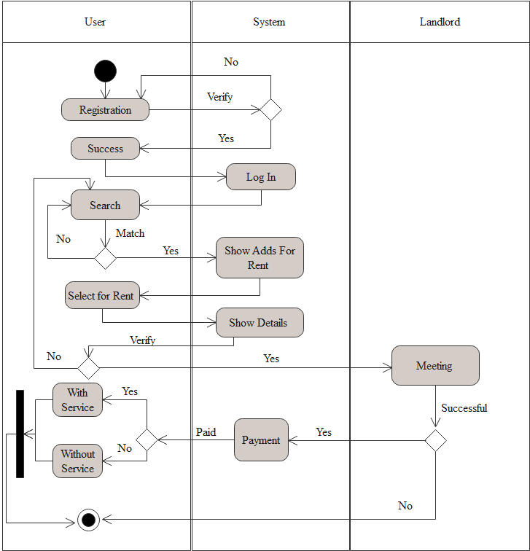

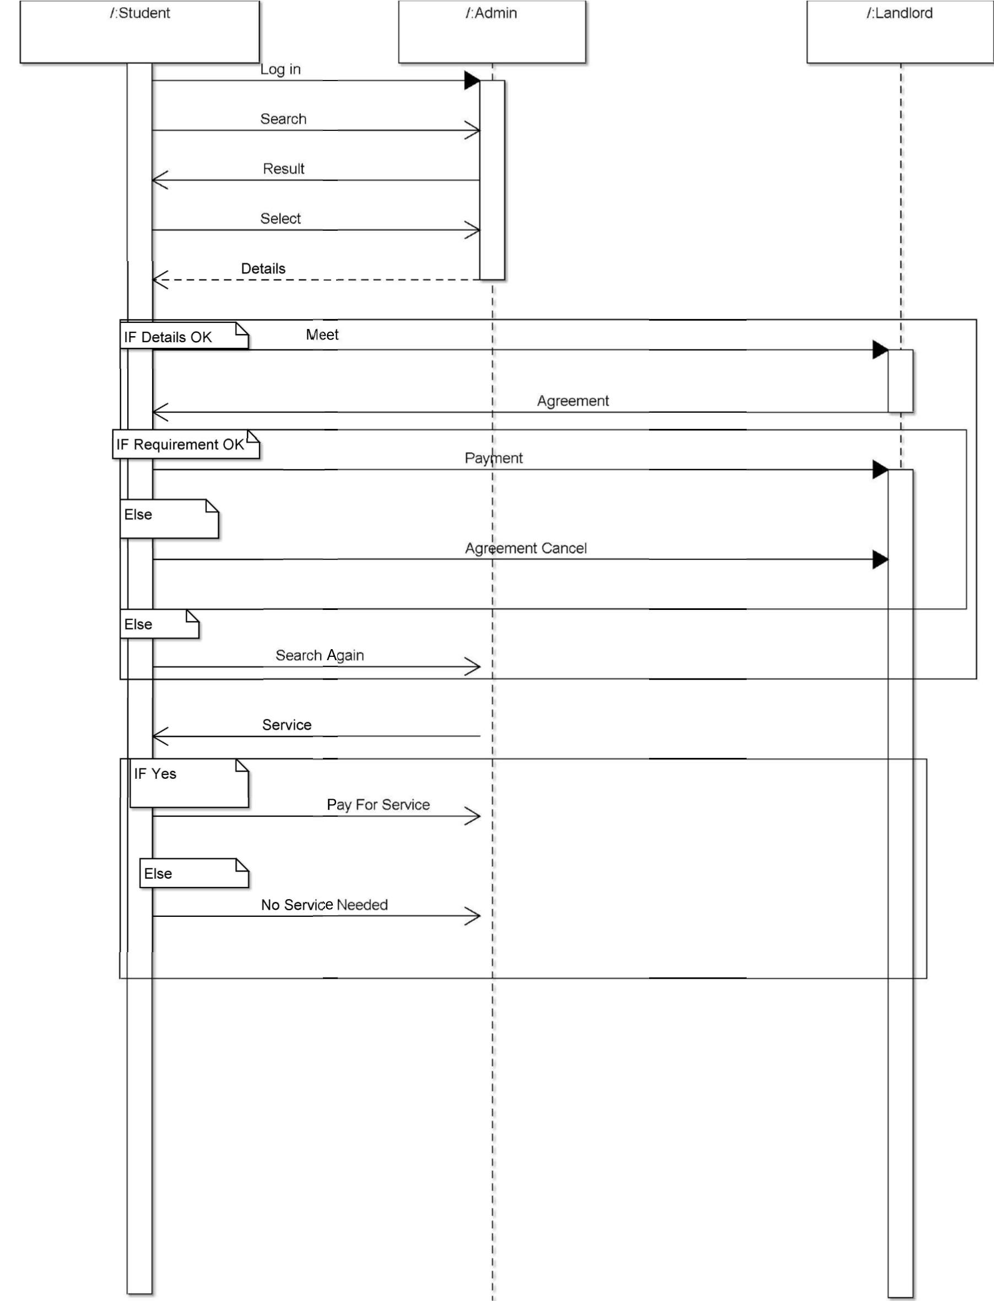**Sequence Diagram:**